Faster Backups with Db2 Intra-Tablespace Parallelis

With Db2 12.1, intra-tablespace parallelism (ITP) for backups was introduced. This new feature addresses long backup runtimes of databases dominated by a single or few large tablespaces. In a lab test at IBM, we examined what you can gain through this new capability.
For SAP systems on IBM Db2 for Linux, UNIX, and Windows (Db2 for LUW), tablespace pools are used to create a balanced tablespace layout. But even with tablespace pools, you can’t always prevent tablespaces from growing more than others.
In this blog post, I’m going to share my findings and some customer results with you. But first, let me give you some more background information about ITP.
Why ITP?
Intra-tablespace parallelism enhances the Db2 parallelism options for backup operations. It’s enabled by default, but you can easily disable it. Simply set the registry variable DB2_BACKUP_ITP to OFF.
Background
Before Db2 12.1, the Db2 backup process assigns a maximum of one Db2 buffer manipulator (db2bm) EDU (engine dispatchable unit) to a tablespace. The first db2bm EDU is assigned to the largest tablespace, then to the second largest, and so on in descending order. The value of the backup parallelization option defines the maximum of db2bm EDUs that are used.
This mechanism scales very well if there are many tablespaces and if the tablespaces are all equally sized.
For databases where one or a few tablespaces are extremely large and the remaining tablespaces are rather small, the overall backup runtime is typically determined by the largest tablespace.
How does ITP work?
Intra-tablespace parallelism (ITP) for backups addresses the above-mentioned database layout challenges. With the ITP feature, tablespaces are logically split into smaller pieces for the backup process. These pieces, called segments, can now be assigned to db2bm EDUs for reading the data. A large tablespace is now accessed by more than one buffer manipulator which speeds up the backup process of this tablespace significantly.
ITP also improves the runtime of compressed and encrypted backups because the workload of performing the compression and encryption can now be spread over multiple cores.
Note
When using ITP, you will only experience a backup runtime improvement if your system provides sufficient bandwidth in the I/O subsystem. Upgrading an existing database to Db2 12.1 automatically enables ITP for backups.
When to use ITP
In case you have an asymmetric tablespace layout with one or several very large tablespaces and a lot of small ones, you should check the backup performance statistics of your recent backups (BARstats) in the db2diag.log. (Don’t’ worry, the BARstats are explained in detail later in this blog post.)
An indicator that ITP can help reduce the overall backup time is the uneven distribution of entries in the performance statistics, like I/O or Mbytes. If you have such an uneven distribution in the performance statistics and your system is not I/O bound, you will most probably benefit from the ITP feature with shorter backup runtimes.

Setup of the test system
Let’s have a look at the results of the lab test at IBM where ITP influenced the backup runtime positively.
The main components of our test environment were:
• POWER LPAR: 8 dedicated physical CPUs, SMT4, 16GB memory
• AIX: 7200-05-07
• IBM disk storage: database
• IBM SSD storage: backup target
• Db2: 12.1
• Database size: 468GB
• Number of tablespaces: 58
• SAP ERP system
The tests were run as offline backups with no additional load on the AIX LPAR. The database was set up with an asymmetric tablespace layout in such a way that the largest tablespace occupied about 263GB and represented 56% of the overall database size. The following chart shows the size of the first 19 out of 58 tablespaces in descending order:

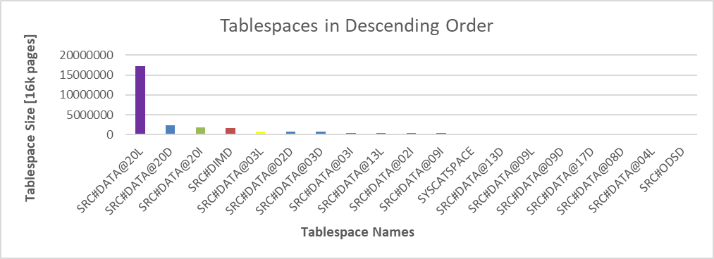

Figure 1: Tablespace layout of the backup environment in descending order

To avoid an overload of the test system’s I/O infrastructure, Db2 backup compression was enabled. The backup parallelization value and the backup targets were defined via the backup command. We used a backup parallelization of four and two targets:

db2 "backup db SRC to <backup target1, backup target 2> with 8 buffers parallelism 4 compress"

Eventually, we ran two backups: The first one with ITP disabled, and the second one with ITP enabled and an ITP parallelization of four (automatically chosen).

Results: Let’s talk numbers
To compare the behavior of the two backups, let’s first have a look at the BARstats entries in the db2diag.log. The tables below are an excerpt of the BARstats with the columns needed for our analysis.
BARstats: ITP disabled
Let’s start with the BARstats for a backup where the ITP feature is disabled. In our case, there are five columns that indicate that we have an asymmetric tablespace layout, and ITP may reduce the overall backup runtime: I/O, Compr, WaitQ, Buffers, and Mbytes.
BM# Total I/O Compr MsgQ WaitQ Throttle Buffers MBytes
----- -------- -------- -------- -------- -------- -------- -------- ---------
000 1:37:59 0:07:03 1:30:12 0:00:00 0:00:00 0:00:00 16778 269690
001 1:37:59 0:01:51 0:20:13 0:00:00 1:15:52 0:00:00 2263 65676
002 1:37:59 0:02:00 0:20:04 0:00:00 1:15:52 0:00:00 1945 71132
003 1:37:59 0:02:04 0:20:01 0:00:00 1:15:52 0:00:00 2132 71909
----- ---------- ---------- -------- -------- -------- -------- -------- --------
TOT - - - - - - 23118 478409

Table 1: ITP disabled - Backup Performance Statistic (BARstats) of an asymmetric tablespace layout.

The first column of interest is the I/O column which lists the time the individual db2bm EDUs spent for reading data from the storage infrastructure. The db2bm EDU BM#000 is active for about seven minutes whereas the other three are only active for about 2 minutes.
The Compr column shows that these three db2bm EDUs were active for about 20 minutes to compress data for the backup, whereas the db2bm EDU BM#000 did most of the work and was active for about 1h and 30 minutes . In summary, these three EDUs were most of the time idle as the entries in the WaitQ column show in accordance with the Compr and I/O column.
The last two columns in the table (Buffers and Mbytes) describe the same behavior merely from the amount of transferred data or used buffers. The db2bm EDU BM#000 needs to transfer about 270GB of data (the complete data of the largest tablespace) whereas the three remaining EDUs only transfer about 70GB each for all other tablespaces.
With ITP disabled, a db2bm EDU is only able to back up one tablespace. Therefore, three db2bm EDUs are idle most of the time after they saved about 44 percent of the database data.
The db2bm EDU BM#000 needs to back up about 56 percent of the data – the largest tablespace - and so determines the overall backup runtime.
Finally, this system behavior leads to a backup runtime of 1h 37m 59s. The backup runtime is represented by the column “Total” in table 1.
Now let’s check how the backup runtime changes after we enable the ITP feature.

BARstats: ITP enabled
AftAfter ITP is enabled, the uneven I/O distribution over the db2bm EDUs disappears and the overall backup runtime reduces significantly to about 44 minutes as shown in column “Total”.
BM# Total I/O Compr MsgQ WaitQ Throttle Buffers MBytes
----- -------- -------- -------- -------- -------- -------- -------- ---------
000 0:44:14 0:04:22 0:39:37 0:00:00 0:00:00 0:00:00 5800 117628
001 0:44:14 0:04:32 0:39:29 0:00:00 0:00:00 0:00:00 5792 121651
002 0:44:14 0:04:26 0:39:33 0:00:00 0:00:00 0:00:00 5928 118155
003 0:44:14 0:04:27 0:39:32 0:00:00 0:00:00 0:00:00 5598 120973
----- -------- -------- -------- -------- -------- -------- -------- ---------
TOT - - - - - - 23118 478409

Table 2: ITP enabled - Backup Performance Statistic (BARstats) of an asymmetric tablespace layout

All db2bm EDUs now spent the same amount of time reading data, about 4m 30s as displayed in the I/O column. Also, the unevenness of the entries in the other columns Compr, WaitQ, Buffers and MBytes vanishes. The db2bm EDUs now use the same amount of time for compressing the data (Compr column), the same number of buffers (Buffers column), and handle the same amount of data (MBytes column). The three entries in the WaitQ column are reduced to zero because the three db2bm EDUs are not waiting for db2bm EDU BM#000 anymore.

Due to the split of the tablespaces into smaller segments, all db2bm EDUs can now backup data from the largest tablespace. All four db2bm EDUs are now equally used and back up nearly the same amount of data. Compared to the previous BARstats db2bm EDU BM#001, BM#002 and BM#003 nearly doubled the processed data from about 70GBytes to 120GBytes.

CPU, disk I/O and runtime comparison
After comparing the BARstats entries for the two backups, let’s now check the CPU and disk I/O resource usage.
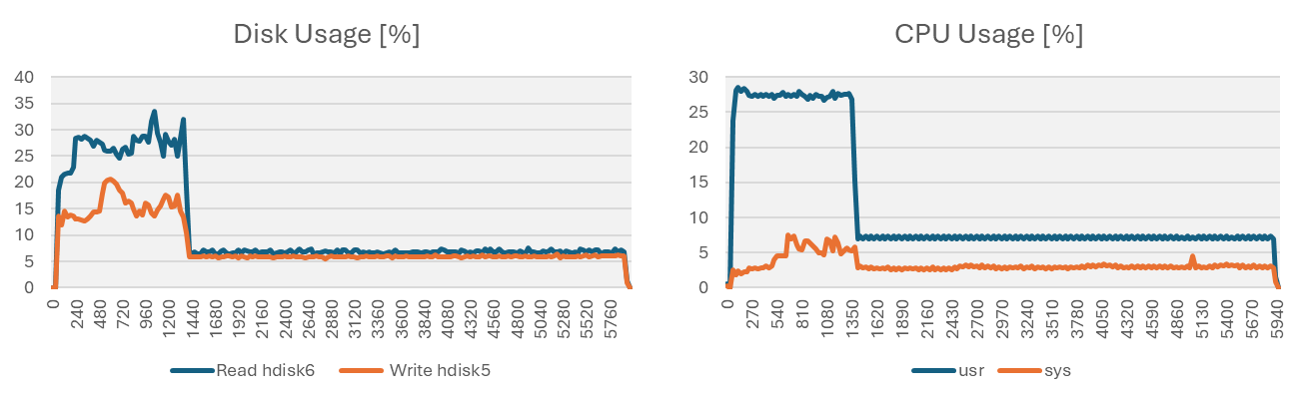
Figure 2: Disk and CPU consumption for backups with asymmetric tablespace layout without ITP

Figure 2 shows that the backup with ITP disabled can use the four db2bm EDUs only at the beginning until about 1440s of the total runtime. From there, only one db2bm EDU keeps working on the data of the largest tablespace. At that point, the I/O and CPU consumption drops to about 25% of the previously used resources (from about 27% to about 7% for read hdisk6) because the available CPU and I/O resources can’t be fully used anymore, and the backup runs for 5870 seconds.
However, with ITP enabled, the work is distributed evenly over all four db2bm EDUs from the beginning as figure 3 shows. All CPU and disk I/O resources are used over the complete time range very efficiently, and therefore the backup runtime is reduced to 2654 seconds.

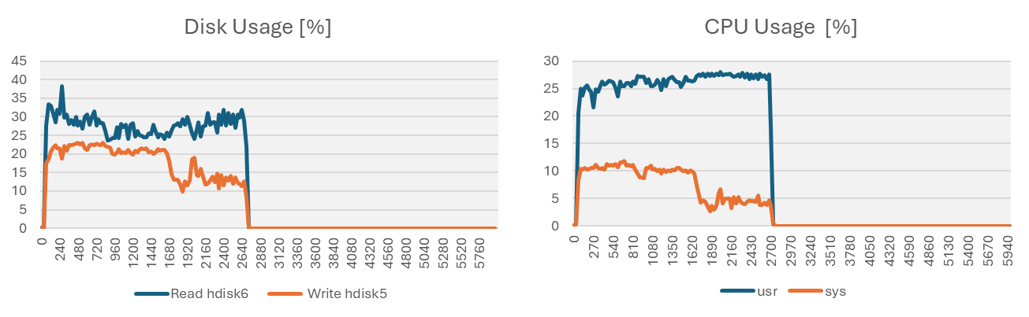

Figure 3: Disk and CPU consumption for backups with asymmetric tablespace layout with ITP

Benefits with ITP
Table 3 shows how advantageous the usage of ITP backup was for our test system with one very large tablespace that contained more than 50% of all data. The overall runtime shrinks from 5879 seconds to 2654 seconds – only 45 percent of the original runtime.

Backup Type | ITP OFF | ITP ON
Total Backup Runtime in [s] | 5879 | 2654
Backup Runtime in [%] | 100% | 45%
Table 3: Backup runtime comparison with and without ITP

Customer backup improvements

Database Name | Runtime Db2 11.5 | Runtime Db2 12.1 | Database Size [TB] | Runtime Advantage | TBS-Pool
ABC | 0h32m | 0h21m | 0,758 | 1.5 | No
DEF | 8h23m | 1h23m | 2,6 | 6.1 | No
GHI | 9h22m | 3h55m | 13,1 | 2.4 | No
JKL | 6h48m | 5h47m | 21 | 1.4 | No
MNO | 13h43m | 2h42m | 8 | 5.1 | No
PQR | 1h30m | 1h30m | 5 | 1.0 | Yes
STU | 1h15m | 0h28m | 0,754 | 2.7 | No
Table 7: Performance gains through ITP reported from customer systems
Now let's have a look at the numbers customers measured after they moved from Db2 11.5 to Db2 12.1. To make it short: All systems benefited from parallelizing the backup process. Two systems, DEF and MNO, benefited more than the others. Why?
These two databases are skewed more than the others, with about 90% of the data in two tablespaces. They achieved a runtime advantage of factor 5.1 and 6.1 faster. For the other databases, the performance gain was between factor 1.4 and 2.7. Only one database, PQR, did not show any runtime increase for the backup. This is due to the use of tablespace pools (TBS-Pools), a well-known feature among SAP customers. The idea behind tablespace pools is to distribute data evenly across all tablespaces. As this was achieved, there was no further performance gain, and the runtime remained stable.

Behind the scenes

The next two tables (no. 4 and 5) show how the tablespaces (TS) are processed by the four db2bm EDUs that are responsible for reading data from disk. For comparison, have a look again at figure 1 from the beginning that shows the sizes of the largest tablespaces.

Table 4 presents the schedule for the backup with ITP disabled. Here we start the backup with reading the data from the four largest tablespaces. Since one db2bm EDU can handle only one tablespace at a time, the largest tablespace (SRC#DATA@20L), which is processed by the db2bm EDU 0, is active during the complete backup runtime. The other three db2bm EDUs process the remaining tablespaces one after the other.

These three db2bm EDUs finish nearly at the same time after about 22 minutes of the total backup runtime of 97 minutes and are then idle until the backup finishes.

Timestamp / db2bm EDU # 0 1 2 3
---------------|------------------|------------------|------------------|------------------|
13.45.02.000000|Start of Backup |
---------------|------------------|------------------|------------------|------------------|
13.45.03.096453|SRC#DATA@20L | | | |
13.45.03.096456| | | |SRC#DIMD |
13.45.03.096457| | |SRC#DATA@20I | |
13.45.03.096469| |SRC#DATA@20D | | |
13.52.29.295925| | | |SRC#DATA@03L |
13.53.39.207200| | |SRC#DATA@02D | |
13.56.41.000506| | | |SRC#DATA@03D |
13.57.53.212139| |SRC#DATA@03I | | |
13.58.06.599882| | |SRC#DATA@13L | |
14.00.01.537700| | |SRC#DATA@02I | |
14.00.09.688030| |SRC#DATA@09I | | |
14.00.51.868637| | | |SYSCATSPACE |
14.01.47.996852| | |SRC#DATA@13D | |
14.01.53.095197| |SRC#DATA@09L | | |
14.02.03.169407| | | |SRC#DATA@09D |
14.02.54.793442| |SRC#DATA@17D | | |
14.03.26.059051| | | |SRC#DATA@08D |
14.03.30.815917| | |SRC#DATA@04L | |
14.04.14.495357| | |SRC#ODSD | |
14.04.18.781050| |SRC#DATA@13I | | |
14.04.49.763706| | | |SRC#DATA@17I |
14.04.58.563706| |SRC#DATA@15D | | |
14.05.07.901921| | |SRC#DATA@04D | |
14.05.28.185044| | | |SRC#DATA@07D |
14.05.40.904507| |SRC#DATA@19D | | |
14.05.49.049745| | |SAPEVENTMON | |
14.06.05.561985| | | |SRC#DATA@15I |
14.06.19.474649| |SRC#DATA@08I | | |
14.06.21.979436| | |SRC#DATA@19I | |
14.06.29.282605| | | |SRC#DATA@07I |
. . . . . . . . . . . . . . . .
. . . . . . . . . . . . . . . .
14.07.09.747728| | |CDHDRLI | |
14.07.09.776252| |Finished TS | | |
14.07.09.816431| | |Finished TS | |
14.07.09.819221| | | |Finished TS |
15.23.01.752967|Finished TS | | | |
---------------|------------------|------------------|------------------|------------------|

Table 4: Schedule of the tablespaces handled by the db2bm EDUs – with ITP disabled

Table 5 presents the schedule for the backup with ITP enabled - by default starting with Db2 12.1. Since we enabled ITP, the tablespaces are now logically split into smaller pieces called segments. Each of these segments can now be handled by a db2bm EDU.
As you can see below, the backup is still starting with the largest tablespaces, but now all db2bm EDUs can work on the same tablespace at the same time, which is shown below for tablespace SRC#DATA@20L.

In this case, the largest tablespace SRC#DATA@20L is the first tablespace completely saved. Nearly all segments of the four largest tablespaces are saved before the db2bm EDUs start working on the smaller tablespaces – in our case SRC#DATA@03L. At the end of the backup, all four db2bm EDUs finish their work at the same time and none of them was idle
.

Timestamp / db2bm EDU # 0 1 2 3
---------------|------------------|------------------|------------------|------------------|
15.25.56.000000|Start of Backup (9 Segments per TS) |
---------------|------------------|------------------|------------------|------------------|
15.25.56.365226| | | |SRC#DIMD |
15.25.56.365226|SRC#DATA@20L | | | |
15.25.56.365228| |SRC#DATA@20I | | |
15.25.56.365229| | |SRC#DATA@20D | |
15.25.56.408031|SRC#DATA@20L | | | |
15.25.56.494002| | | |SRC#DATA@20L |
15.25.56.562859| |SRC#DATA@20L | | |
15.25.56.571291| | |SRC#DATA@20L | |
15.38.58.951571| |SRC#DATA@20L | | |
15.39.07.185731| | |SRC#DATA@20L | |
15.39.15.986143| | | |SRC#DATA@20L |
15.39.35.801766|SRC#DATA@20D | | | |
15.41.15.915408|SRC#DATA@20L | | | |
15.52.41.409140| |SRC#DATA@20D | | |
15.53.09.022710| | |SRC#DATA@20I | |
15.53.34.586421| | | |SRC#DIMD |
15.54.12.050136| | |SRC#DATA@20D | |
15.54.17.009638| |SRC#DATA@20I | | |
15.54.32.022147| | | |SRC#DIMD |
15.55.20.261938| |SRC#DATA@20D | | |
15.55.26.876205|SRC#DATA@20I | | | |
15.55.30.352685| | | |SRC#DIMD |
15.55.47.655002| | |SRC#DATA@20I | |
15.56.27.127380| | | |SRC#DATA@20D |
15.56.28.746685|SRC#DIMD | | | |
15.56.51.419783| | |SRC#DATA@20I | |
15.56.58.371327| |SRC#DIMD | | |
15.57.25.690177|SRC#DATA@20D | | | |
15.57.54.919289| |SRC#DATA@03L | | |
15.57.54.998396| |SRC#DATA@03L | | |
. . . . . . . . . . . . . . . .
. . . . . . . . . . . . . . . .
16.10.10.037158| | | |SRC#FACTD |
16.10.10.065459| | | |Finished TS |
16.10.10.065471| | |Finished TS | |
16.10.10.070351|Finished TS | | | |
16.10.10.088478| |Finished TS | | |
---------------|------------------|------------------|------------------|------------------|

Table 5: Schedule of the tablespaces handled by the db2bm EDUs – with ITP enabled

Table 6 shows the number of segments of the four largest tablespaces that are saved before the backup of a smaller tablespace starts (SRC#DATA@03L). At that point in time, the largest tablespace with its 9 segments is completely saved and so are 28 of 36 segments of the four largest ones. As you can see, large tablespaces are prioritized by the scheduler.
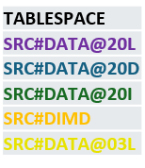
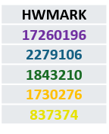
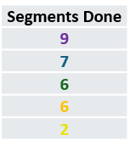
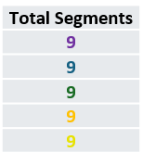

Table 6: Number of segments already stored in the backup when the fifth largest tablespace starts getting saved.

What about restore?
Now that I’ve shown you that it can be beneficial to use ITP backups for databases with one or a few large tablespaces, the question remains: Are there any drawbacks for the case when backups are made for a database restore?
The short answer is no. In our lab test environment, there was no runtime difference for restoring a backup made with or without ITP enabled. In both cases, the restore took us about 2200 seconds.
Conclusion
The feature intra-tablespace parallelism (ITP) is by default enabled for Db2 versions as of 12.1. It’s advantageous for database implementations that are dominated by one or few very large tablespaces, while it does not harm implementations with equally sized tablespaces. Such implementations always have issues with long backup runtimes caused by the large tablespace(s). Because as of Db2 12.1, the new ITP feature splits all tablespaces logically into smaller segments, the backup runtime will shrink.
In the IBM lab environment, we found that the backup runtime of our database with an asymmetric tablespace layout decreased significantly. In our case, with the largest tablespace representing about 56 % of the whole database, we achieved a backup runtime reduction up to 45% of the previous runtime. Keep in mind that the system needs free I/O capacity to leverage the new backup parallelization successfully. Systems at customer sites verified the internal measurements with a runtime improvement of up to 6.1.
What do you think of the ITP feature? Have you tried it yourself? Let me know in the comments.

